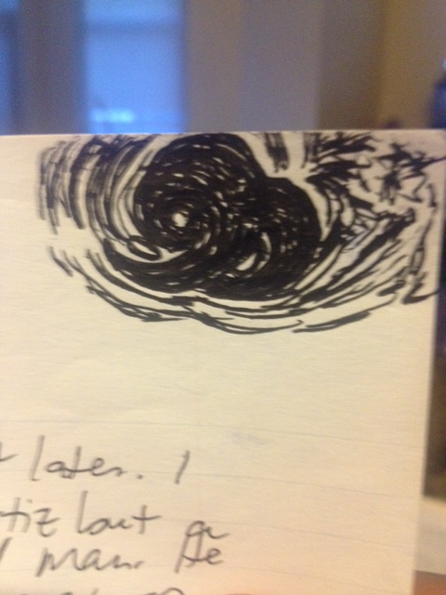

It’s still the same day but a bit later. I just saw the doc – it was not Dr. Ortiz but a grey-haired senior citizen Dr. man. He seemed like he cared but there was only so much he could do. He says I need a neurologist. I agree. I’m in a stall at the VA – in the bathroom. It seems safe in here. And, I guess it makes my ID happy. People think I could be a PA. People believe in me. They think I can do anything I want to. What do I think?